LAB MANUAL

SESSION - JAN 2026

JAVA
PROGRAMMING
LAB
PC/CSE/46-P

LIST OF PROGRAMS
Course Title: JAVA PROGRAMMING LABORATORY
Sr.No | Name of Programs | Page No.
1. | Write a simple java application, to print the message, "Welcome to java"
2. | Write a program to display the month of a year. Months of the year should be held in an array.
3. | Write a program to demonstrate a division by zero exception
4. | Write a program to create a user defined exception say Pay Out of Bounds.
5. | Write a java program to add two integers and two float numbers. When no arguments are supplied, give a default value to calculate the sum. Use function overloading.
6. | Write a program to perform mathematical operations. Create a class called AddSub with methods to add and subtract. Create another class called MulDiv that extends from AddSub class to use themember data of the super class. MulDiv should have methods to multiply and divide A main function should access the methods and perform the mathematical operations.
7. | Write a program with class variable that is available for all instances of a class. Use static variable declaration. Observe the changes that occur in the object's member variable values.
8. | Write a java program to create a student class with following attributes: Enrollment id: Name, Mark of subl, Mark of sub2, mark of sub3, Total Marks. Total of the three marks must be calculated only when the student passes in all three subiects. The pass mark for each subiect is 50. If a candidate fails in any one of the subiects his total mark must be declaredas zero. Using this condition write a constructor for this class. Write separate functions for accepting and displaying student details. In the main method create an array of three student objects and display the details.
9. | In a college first year class are having the following attributesName of the class (BCA, BCom, BSc), Name of the staff, No of the students in the class, Array of students in the class
10. | Define a class called first year with above attributes and define a suitable constructor. Also write a method called best Student() which process a first-year object and return the student with the highest total mark. In the main method define a first-year object and find the best student of this class
11. | Write a java program to define a class called employee with the name and date of appointment. Create ten employee objects as an array and sort them as per their date of appointment. ie, print them as per their seniority.
12. | Create a package' student.Fulltime.BCA' in your current working directory  a. Create a default class student in the above package with the following attributes: Name, age, sex. b. Have methods for storing as well as displaying
13. | Write a small program to catch Negative Array Size Exception. This exception is caused when the array is initialized to negative values.
14. | Write a program to handle Null Pointer Exception and use the "finally" method to display a message to the user.
15. | Write a program to create an applet and draw grid lines Program:
16. | Write a program which creates a frame with two buttons father and mother. When we click the father button the name of the father, his age and designation must appear. When we click mother similar details  of mother also appear.
17. | Write a java Program to create a window when we press Mor m the window displays Good Morning, A or a the window displays Good After Noon E or e the window displays Good Evening, N or n the window displays Good Night
18. | Demonstrate the various mouse handling events using suitable example.

DOs and DON’Ts in Laboratory:

1. Make entry in the Log Book as soon as you enter the Laboratory.
2. All the students should sit according to their roll numbers starting from their left to right.
3. All the students are supposed to enter the terminal number in the log book.
4. Do not change the terminal on which you are working.
5. All the students are expected to get at least the algorithm of the program/concept to be implemented.
6. Strictly observe the instructions given by the teacher/Lab Instructor.
7. Do not disturb machine Hardware / Software Setup.

Instruction for Laboratory Teachers:

1. Submission related to whatever lab work has been completed should be done during the next lab session along with signing the index.
2. The promptness of submission should be encouraged by way of marking and evaluation patterns that will benefit the sincere students.
3. Continuous assessment in the prescribed format must be followed.

Program No 1.
Write a simple java application, to print the message, "Welcome to java"
Program:

class Labl{

public static void main(String args[])

{

System.out.println("Welcome to java");

}

}

Output:

Welcome to java

Program No 2.
Write a program to display the month of a year. Months of the year should be held in an array.
Program:

import java.util.Calendar; class Lab2{
public static void main(String args[]){ Calendar calendar=Calendar.getlnstance();
String
mon [l--{"JanII ,"Feb","March","Apn., ..,"MayII ,"JuneII ,"JuIyII ,"AugII ,"Sept","Oct" ,"N ov
II ,"Dec"};

System.out.println(calendar.get(Calendar.MONTH)); System.out.println("Current Month="+man[calendar.get(Calendar.MONTH)]);
}

}

Output:

5

Current Month=June

Program No 3.
Write a program to demonstrate a division by zero exception

Program:

class Lab3{

public static void main (String args[]) { int num1 = 15, num2 = 0, result= O; try{
result= numl/num2; System.out.println("The result is" +result);
}

catch (ArithmeticException e) {

System.out.println ("Can't be divided by Zero:"+ e);
}

}

}

Output:

Can't be divided by Zero: java.lang.ArithmeticException: / by zero

Program No 4.

Write a program to create a user defined exception say Pay Out of Bounds.
Program:
import java.util.*;

class PayoutOfBoundsException extends Exception{ PayoutOfBoundsException(String msg){ System.out.println("Pay out of bound exception:"+msg);
}

}

public class Lab4{

public static void main(String args[]) throws PayoutOfBoundsException{ System.out.println("Enter the emp salary");
Scanner sc=new Scanner(System.in); int pay=sc.nextlnt();
if(pay<10000 11 pay>SO000){

throw new PayoutOfBoundsException("salary not in valid range");

}else

System.out.println("Emp is eiligible for 30% hike");

}

}

Output 1:
Enter the emp salary 60000
Pay out of bound exception:salary not in valid range Exception in thread "main" PayoutOfBoundsException
at Lab4.main(Lab4.java:16)

Output 2:
Enter the emp salary 30000
Emp is eiligible for 30% hike

Program No 5.
Write a java program to add two integers and two float numbers. When no arguments are supplied, give a default value to calculate the sum. Use function overloading.

Program:

class Labs{

static int add(int a, int b){ return a+b;
}

static float add(float x, floaty){ return x+y;
}

static int add(){

return (50+50);

public static void main(String args[]){

int int_sum=add(l0,13);

float flt_sum=add(12.2f,10.0f);

System.out.println("addof int is:"+int_sum);

System.out. println("Add of float is:"+flt_sum);

System.out.println("CallingDefault addition"); int deft=add();
System.out.println("Default add:"+deft);

Output:

add of int is:23 Add of float is:22.2
Calling Default addition Default add:100

Program No 6.
Write a program to perform mathematical operations. Create a class called AddSub with methods to add and subtract. Create another class called MulDiv that extends from AddSub class to use the member data of the super class. MulDiv should have methods to multiply and divide A main function should access the methods and perform the mathematical operations.
Program:

class AddSub{

int n1,n2;

public AddSub(int x, int y)

{

nl=x; n2=y;
}

publie int add(){ return(n1+n2);
}

public int sub(){ return(n1-n2);
}

}

class MulDiv extends AddSub{ public MulDiv(int x, int y){ super(x,y);
}

public int mul(){ return(nl*n2);
}

public int div(){ return(n1/n2);
}

}

class Lab6{

public static void main(String args[)){ MulDiv md=new MuIDiv(20,10);
System.out.println("Sum of (20,l0)is:"+md.add()); System.out.println("Substraction of (20,l0)is:"+md.sub()); System.out.println("Multiplication of (20,l0)is:"+md.mul()); System.out.println("Division of (20,l0)is:"+md.div());
}

}

Output:

Sum of (20,l0)is:30 Substraction of (20,l0)is:10 Multiplication of (20,lO)is:200 Division of (20,l0)is:2

Program No 7.

Write a program with class variable that is available for all instances of a class. Use static variable declaration. Observe the changes that occur in the object's member variable values.
Program:

class Student{

static String collegeName="KLE"; int rno;
String sname;

public Student(int no, String nm){ rno=no;
sname=nm;

}

void display(){

System.out.println(collegeName+" "+rno+" "+sname);

}

}

public class Lab7{

public static void main(String args[]){

System.out.println("Objects sharing the static variable collegename"); Student sl=new Student(l,"Sri");
Student s2=new Student(2,"Ram"); sl.display();
s2.display();

System.out.println("Static value is changed by one of the object"); sl.collegeName="KLESNC";
s1.display();

s2.display();

}

}

Output:

Objects sharing the static variable collegename KLE 1 Sri
KLE 2 Ram

Static value is changed by one of the object KLESNC 1 Sri
KLESNC 2 Ram

Program No 8.
Write a java program to create a student class with following attributes: Enrollment id: Name, Mark of subl, Mark of sub2, mark of sub3, Total Marks. Total of the three marks must be calculated only when the student passes in all three subiects. The pass mark for each subiect is 50. If a candidate fails in any one of the subiects his total mark must be declaredas zero. Using this condition write a constructor for this class. Write separate functions for accepting and displaying student details. In the main method create an array of three student objects and display the details.
Program:

import java.util.*;

class Student{

Scanner sc=new Scanner(System.in); String Eid;
String name;

int subl, sub2,sub3, total;

Student(){ getlnfo();
}

public void getlnfo(){ System.out.println("**Student details**"); System.out.println("Enter Enrollment ID"); Eid=sc.next();
System.out.println("Enter Name");

name=sc.next(); System.out.println("Enter marks"); subl=sc.nextlnt();
sub2=sc.nextlnt(); sub3=sc.nextlnt();

if(subl >=SO && sub2 >=50 && sub3 >=SO){ total=subl +sub2+sub3;}
else{ total=O;
}

}

public void display(){ System.out.println(Eid+"\t\t"+name+"\t\t"+total);
}

}

class Lab8{

public static void main(String args[]){ Student s[]=new Student[3];

for(int i=0;i<3;i++){ s[i]=new Student();
}

System.out.println("***Student Details***"); System.out.println("Eid"+11\ t\t"+11 name11 +11\t\t" +"total11
);
for( int i=0;i<3;i++){ s[i].display();
}

}

}

Output:
Enter Enrollment ID

s1

Enter Name sri
Enter marks

66

67

68

**Student details** Enter Enrollment ID

s2

Enter Name ram
Enter marks

78

87

67

* *Student details** Enter Enrollment ID s3
Enter Name hari
Enter marks

98

78

65

***Student Details***

Eid | name | total
sl | Yi | 201
s2 | ram | 232
s3 | hari | 241

Program No 9.
In a college first year class are having the following attributesName of the class (BCA, BCom, BSc), Name of the staff, No of the students in the class, Array of students in the class
Program:

import java.util.*;

class FirstYear{ String classname; String classteacher; int stdcount;
int stdmarks[]= new int[SO];

String stdnames[] = new String[SO]; Scanner sc = new Scanner(System.in);

public FirstYear() { getinfo();
}

public void getinfo() {

System.out.println("Please Enter the class Name:");

classname = sc.nextline();

System.out.println("Please Enter the class Teacher Name:"); classteacher = sc.nextline();
System.out.println("Please Enter the Total number of students of the

class:");
stdcount = lnteger.parselnt(sc.nextline()); System.out.println("Please Enter the Names of all the students of the

class:");

for(int i=O;i<stdcount;i++) stdnames[i]=sc.nextline();
System.out.println("Please Enter the marks of all the students of the

class:");

for(int i=O;i<stdcount;i++) stdmarks[i] =sc.nextInt();
}

public void bestStudent(){ int best=O, k=-1;
for(int i=O;i<stdcount;i++) { if(stdmarks[i] > best) {
best :cc stdmarks[i]; k=i;

}

}

System.out.println("The Best Student is "+stdnames[k]);

}

}

public class Lab9{

public static void main(String args[]){ FirstYear fy = new FirstYear(); fy.bestStudent();
}

}

Output:
Harshada

Please Enter the Total number of students of the class: 3
Please Enter the Names of all the students of the class:

A B C
Please Enter the marks of all the students of the class:

78
87
88

The Best Student is c
Program No 10.
Define a class called first year with above attributes and define a suitable constructor. Also write a method called best Student() which process a first-year object and return the student with the highest total mark. In the main method define a first-year object and find the best student of this class
Program:
class FirstYear {
String name;
int rollNo;
int mark1, mark2, mark3;

// Constructor
FirstYear(String name, int rollNo, int mark1, int mark2, int mark3) {
this.name = name;
this.rollNo = rollNo;
this.mark1 = mark1;
this.mark2 = mark2;
this.mark3 = mark3;
}

// Method to calculate total marks
int getTotal() {
return mark1 + mark2 + mark3;
}

// Static method to find best student
static FirstYear bestStudent(FirstYear s1, FirstYear s2, FirstYear s3) {
FirstYear best = s1;

if (s2.getTotal() > best.getTotal()) {
best = s2;
}
if (s3.getTotal() > best.getTotal()) {
best = s3;
}

return best;
}
}

public class Main {
public static void main(String[] args) {
// Creating objects
FirstYear s1 = new FirstYear("Aman", 1, 85, 90, 88);
FirstYear s2 = new FirstYear("Riya", 2, 92, 91, 89);
FirstYear s3 = new FirstYear("Karan", 3, 80, 85, 84);

// Finding best student
FirstYear best = FirstYear.bestStudent(s1, s2, s3);

// Display result
System.out.println("Best Student:");
System.out.println("Name: " + best.name);
System.out.println("Roll No: " + best.rollNo);
System.out.println("Total Marks: " + best.getTotal());
}
}

Output:

Best Student:

Name: Riya

Roll No: 2

Total Marks: 272
Program No 11.
Write a java program to define a class called employee with the name and date of appointment. Create ten employee objects as an array and sort them as per their date of appointment. ie, print them as per their seniority.

Program:
import java.util.Date; class Employee {
String name;

Date appdate;

public Employee(String nm, Date apdt){ name=nm;
appdate=apdt;

public void display(){

System.out. println("employee name:"+name+"\t appointment date:\t"+appdate.getDate()+"/"+ appdate.getMonth()+"/"+appdate.getYear());
}

public class Labll{

public static void main(String args[]){

Employee emp[]=new Employee[lO);

emp[O]=new Employee("Neeraja k", new Date(1999,05,22)); emp[l)=new Employee("roja D",new Date(2009,04,25)); emp[2)=new Employee("rana k",new Date (2005,02,19)); emp[3]=new Employee("jothika", new Date(2009,01,01)); emp[4)=new Employee("srikanth",new Date(1999,01,01)); emp[S]=new Employee("rajesh",new Date(2020,05,19)); emp[6]=new Employee("asha",new Date(2000,01,25)); emp[7]=new Employee("ammu",new Date(2022,04,22)); emp[8)=new Employee("gourav",new Date(2002,9,9)); emp[9)=new Employee("kuldeep",new Date(2000,01,19));

System.out.println("list of employees Before sorting"); for(int i=O;i<emp.length;i++)
emp[i].display();

for(int i=0;i<emp.length;i++){

for(int j=i+l;j<emp.length;j++){

if( emp[i].appdate.after(emp[j].appdate)){ Employee t= emp[i];
emp[i]=empU]; empU]=t;

}

System.out. println("\nlist of employees seniority wise"); for(int i=0;i<emp.length;i++)
emp[i].display();

Output:
list of employees Before sorting
employee name:Neeraja k appointment date: | 22/5/1999
employee name:roja D appointment date: | 25/4/2009
employee name:rana k appointment date: | 19/2/2005
employee name:jothika appointment date: | 1/1/2009
employee name:srik,mth appointment date: | 1/1/1999

employee name:rajesh | appointment date: | 19/5/2020
employee name:asha | appointment date: | 25/1/2000
employee name:ammu | appointment date: | 22/4/2022
employee name:gourav | appointment date: | 9/9/2002
employee name:kuldeep | appointment date: | 19/1/2000
List of employees seniority wise
employee name:srikanth appointment date: |  | 1/1/1999
employee name:Neeraja k appointment date: |  | 22/5/1999
employee name:kuldeep appointment date: |  | 19/1/2000
employee name:asha appointment date: |  | 25/1/2000
employee name:gourav appointment date: |  | 9/9/2002
employee name:rana k appointment date: |  | 19/2/2005
employee name:jothika appointment date: |  | 1/1/2009
employee name:roja D appointment date: |  | 25/4/2009
employee name:rajesh appointment date: |  | 19/5/2020
employee name:ammu appointment date: |  | 22/4/2022

Program No 12.
Create a package' student.Fulltime.BCA' in your current working directory
a. Create a default class student in the above package with the following attributes: Name, age, sex. b. Have methods for storing as well as displaying

Program:
package student.fulltime.bca;
import java.util.Scanner;

public class BCAStudent{ String name, sex;
int age;

Scanner sc=new Scanner(System.in);

public void getdata(){ System.out.println("Student Name:"); name=sc.nextline(); System.out.println("Student Sex:"); sex=sc.nextline();
System.out.println("Student Age:"); age=sc.nextlnt();

public void display(){ System.out.println("Student details are:"); System.out.println("Student Name:"+name); System.out.println("Student Sex:"+sex); System.out.println("Student Age:"+age);
/* NOTE: Save this file by name BCAStudent.java Compile this file by using command:
javac -d . BCAStudent.java

folder hierarchy Student\fulltime\bca will be created and BCAStudent is been placed in bca folder
*/
//save this file as packageDemo.java outside of student folder and execute this file import student.fulltime.bca.BCAStudent;

public class packageDemo{

public static void main(String args[]){ BCAStudent std=new BCAStudent(); std.getdata();
std.display();

Output: Student Name: sri
Student Sex: male Student Age: 23

Student details are: Student Name:sri Student Sex:male Student Age:23

Program No 13.

Write a small program to catch Negative Array Size Exception. This exception is caused when the array is initialized to negative values.

Program:

import java.util.*;

class Lab13

public static void main(String args[])

Scanner sc=new Scanner(System.in); System.out.println("Enter the size of an array:"); int size=sc.nextInt();
try

String[] s=new String[size]; System.out.println("Array is created successfully");

catch(NegativeArraySizeException e)

System.aut. pr intin("Array underflow"); System.out.print!n(e.toString());

Output:

Enter the size of an array:

-2

Array underflow java.lang.NegativeArraySizeException

Program No 14.
Write a program to handle Null Pointer Exception and use the "finally" method to display a message to the user.

Program:

class Lab14{
public static void main(String args[]){

String city=null; try{
if(city.equals("Bangalore")) System.out.println("Equals");
else
System.out.println("not Equals");

}catch(NullPointerException e){
System.out.println("Null Pointer Exception Caught");
}
finally{
System.out.println(" this is finally block after try_catch blk");
}
}
}

Output:

Null Pointer Exception Caught

this is finally block after try catch blk

Program No 15.
Write a program to create an applet and draw grid lines Program:

import java.awt.*;
import java.applet.*;

/*<applet code=Labl 7 width=200 height=200>
</applet>*/

public class Lab17 extends Applet{ public void paint(Graphics g){
int row, column,x,y=20; for(row=l;row<5;row++){
x=20;
for(column=1;column<5;column++){ g.drawRect(x,y,40,40); x=x:+20;
} y=y+20;
}
}
}
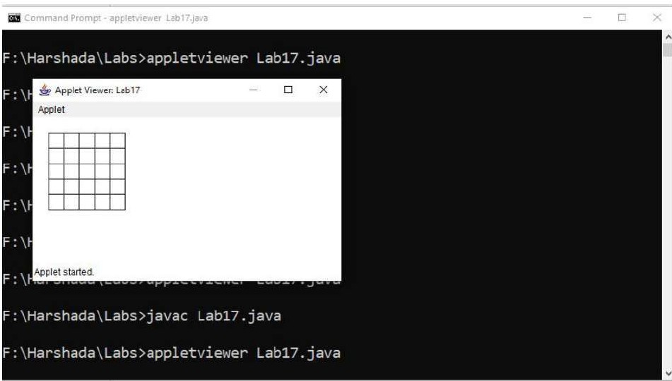
Output:

Program No 16.
Write a program which creates a frame with two buttons father and mother. When we click the father button the name of the father, his age and designation must appear. When we click mother similar details
of mother also appear.

Program

import java.awt.*; import java.awt.event.*;

public class Lab18
{
public static void main(String args[])
{
Frame f = new Frame("Button Event"); Label 1 = new Label("Details of Parents");
l.setFont(new Font("Calibri", Font.BOLD, 16)); final Label n I = new Label();
final Label d I = new Label();
final Label al = new Label(); l.setBow1ds(20,20,500,50); nl.setBounds(20,110,500,30); d l.setBounds(20,150,500,30); al .setBounds(20,190,500,30);
Button mb = new Button("Mother"); mb.setBounds(20,70,50,30);

mb.addActionListener(new ActionListener()
{
public void actionPerformed(ActionEvent e)
{
nl.setText("Name: "+"Aishwarya"); al.setText("Age: "+"42"); dl.setText("Designation: "+"Professor");
}

});

Button fb = new Button("Father"); fb.setBounds(80,70,50,30);

fb.addActionListener(new ActionListener()
{
public void actionPerformed(ActionEvent e)
{

}
});

nl.setText("Name: "+"Ram");
al.setText("Age: "+"45"); dl.setText("Designation: "+"Manager");

f.add(mb);
f.add(fb);
f.add(l);
f.add(nl);
f.add(dl);
f.add(al); f.setLayout(null); f.setSize(250,250); f.setVisible(true);
}
}

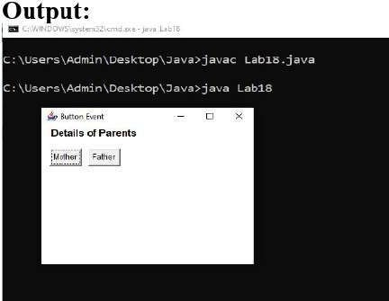
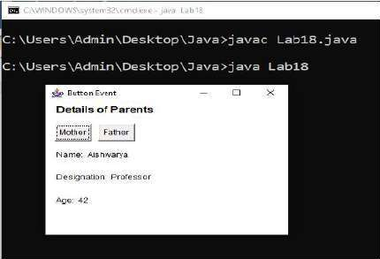

Program No 17.
Write a java Program to create a window when we press Mor m the window displays Good Morning, A or a the window displays Good After Noon E or e the window displays Good Evening, N or n the window displays Good Night

Program:
import java.awt.*; import java.awt.event.*;

public class Lab22 extends Frame implements Keylistener{ Label lbl;
Label I;

Lab22(){

I= new Label("Press the key [ M, A, E, N] to Display Greetings", Label.CENTER); l.set8ounds(50, 50, 300, 50);
add(I);

addKeylistener(this); requestfocus(); lbl=new Label();
Ibl.setBounds(100,100,200,40);

161.setFont( new Font("Calibri",Font.BOLD,16)); add(lbl);
setSize(400,400); setLayout(null); setVisible(true);
}

public void keyPressed(KeyEvent e){ if(e.getKeyChar()== 'M' 11 e.getKeyChar()=='m')
161.setText("Good Morning");

else if(e.getKeyChar()== 'A' 11 e.getKeyChar()=='a') lbl.setText("Good Afternoon");
else if(e.getKeyChar()== 'E' 11 e.getKeyChar()=='e') lbl.setText("Good Evening");
else if (e.getKeyCharO== 'N' 11 e.getKeyChar()=='n') lbl.setText("Good Night");
}

public void keyReleased(KeyEvent e){

}

public void keyTyped(KeyEvent e){

}

public static void main(String args[)){ new Lab22();
}
}

public class Lab22 extends Frame implements Keylistener{ Label lbl;
Label I;

Lab22(){

I= new Label("Press the key [ M, A, E, N] to Display Greetings", Label.CENTER); l.set8ounds(50, 50, 300, 50);
add(I);

addKeylistener(this); requestfocus(); lbl=new Label();
Ibl.setBounds(100,100,200,40);

161.setFont( new Font("Calibri",Font.BOLD,16));

add(lbl);
setSize(400,400); setLayout(null); setVisible(true);
}

public void keyPressed(KeyEvent e){ if(e.getKeyChar()== 'M' 11 e.getKeyChar()=='m')
161.setText("Good Morning");

else if(e.getKeyChar()== 'A' 11 e.getKeyChar()=='a') lbl.setText("Good Afternoon");
else if(e.getKeyChar()== 'E' 11 e.getKeyChar()=='e') lbl.setText("Good Evening");
else if (e.getKeyCharO== 'N' 11 e.getKeyChar()=='n') lbl.setText("Good Night");
}

public void keyReleased(KeyEvent e){

}

public void keyTyped(KeyEvent e){

}

public static void main(String args[)){ new Lab22();
}

}

\

OUTPUT:

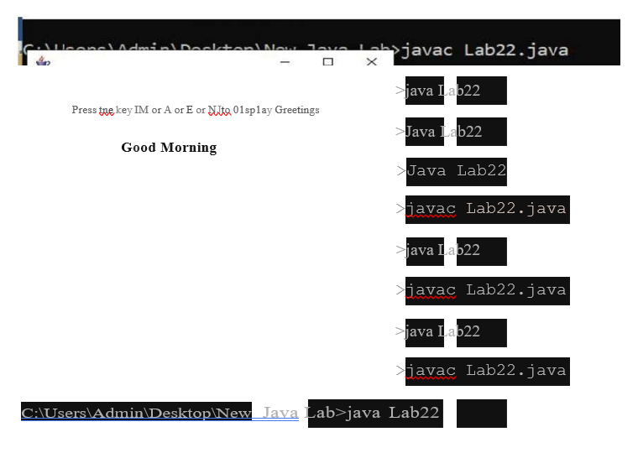

Program No 18.

Demonstrate the various mouse handling events using suitable example.

Program:

import java.awt. *; import java.awt.event. *;
public class Lab23 extends Frame implements Mouselistener{ Label I;
Lab23(){

addMouseListener(this);

l=new Label();

l.setBounds(20,50,100,20);

add(I); setSize(300,300); setlayout(null); setVisible(true);

public void mouseClicked(MouseEvent e) { l.setText("Mouse Clicked");

public void mouseEntered(MouseEvent e) { l.setText("Mouse Entered");

public void mouseExited(MouseEvent e) { l.setText("Mouse Exited");

public void mousePressed(MouseEvent e) { l.setText("Mouse Pressed");

public void mouseReleased(MouseEvent e) { l.setText("Mouse Released");

public static void main(String[] args) { new Lab23();

OUTPUT:

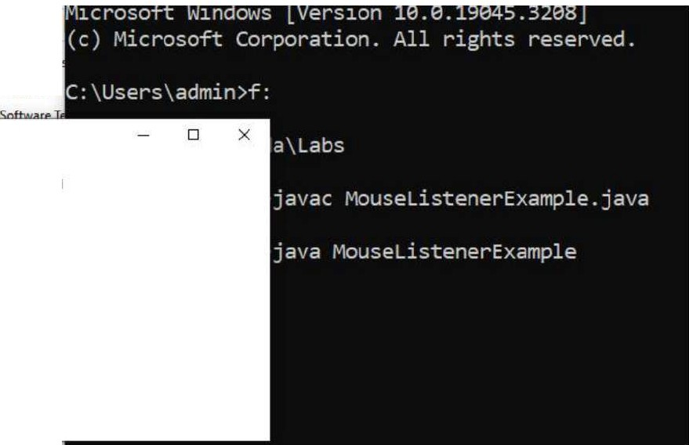
l:fil Document
� Pictures
Mouse Entered

